# Assignment: Dojos and Ninjas

## Objectives:

1. Practice designing ERDs with one-to-many relationships.

Create an ERD to represent the database for an application that tracks dojos and the ninjas that belong to each.

Each dojo should have an id, name, created_at and updated_at; each ninja should have an id, first_name, last_name, age, created_at, updated_at and belong to a specific dojo. Use the MySQL Workbench for creating this diagram.

* Create a new model (ERD)

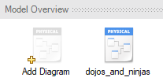

* Name the schema dojos_and_ninjas_schema

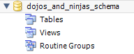

* Create a table called dojos
* Add the following fields to the dojos table: id, name, created_at and updated_at

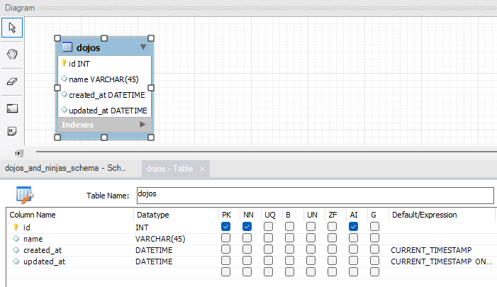

* Create a table called ninjas
* Add the following fields to the ninjas table: id, first_name, last_name, age, created_at, updated_at and create an one to many relationship to the dojos table

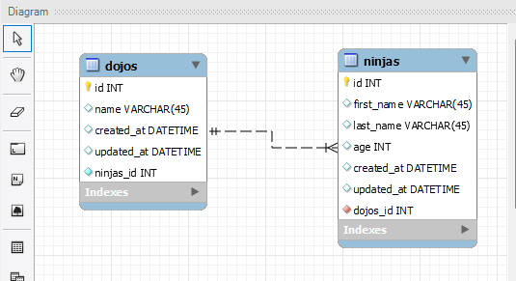

* Change the name of the relationship field to the singular pronoun. ie dojo_id

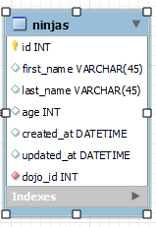

* Save your ERD as a .mwb file and submit it to the platform